TERMS OF REFERENCE
SA Power Networks Vulnerable Customer Advisory Group

- Purpose

SA Networks has a consultative group model, comprising of a Community Advisory Forum and a number of specialised Advisory Groups. This model provides a forum where SA Power Networks can engage with our customer representatives and external stakeholders, to ensure customer views shape our service delivery and decision-making. A copy of the consultative model is provided as an attachment.
Our consultative group model is aligned to the four customer themes that shaped our regulatory reset engagement for the 2030-35 period. While our different advisory groups are aligned under one of the four themes, all four themes should be considered when making decisions in the best interest of customers.

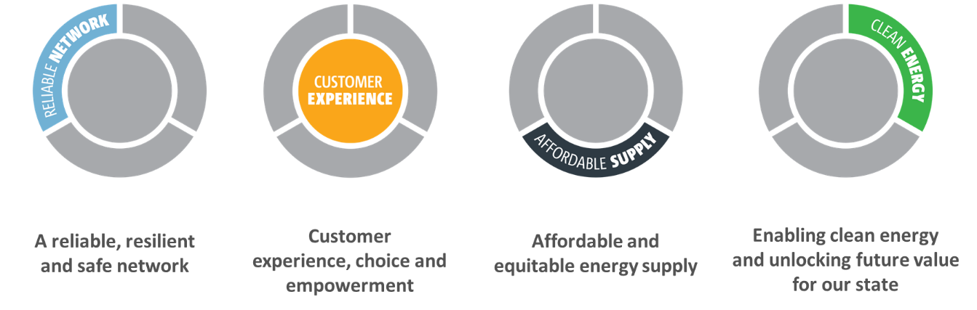

- Role and objectives

The key objectives of the Community Advisory Forum and Advisory Groups are to:
- provide a forum for South Australian representative groups and consumers to engage with SA Power Networks on priority issues and topics.
- provide a forum for listening, discussion and collaborative engagement with customers and stakeholders.
- ensure the interests of customers are considered in decision-making.
- advocate for the needs and priorities of customers.
- build understanding and trust between stakeholders and SA Power Networks.

The key objectives of this Advisory Group are to:
- Discuss energy sector issues facing particular groups within the community, with a focus on customers experiencing disadvantage or vulnerability.
- Identify and implement initiatives to assist vulnerable customers.
- Seek input and feedback into Energy Charter initiatives and reporting requirements.

Engagement principles
SA Power Networks has five key engagement principles that underpin our engagement approach and consultative group model.
- Open and transparent – openly sharing information and outlining our process of decision making
- Engaging and collaborative – the importance of working together in a collaborative manner
- Inclusive and diverse – encourage a diversity of views and different perspectives
- Operating with respect and trust.
- Seeking consensus and mutual understanding where possible.

Shared outcomes/ outputs
At the first meeting of the Advisory Group for 2024, the key objectives and desired outcomes for each group will be discussed and agreed. The shared outcomes agreed by each Advisory Group will be reviewed to monitor effectiveness and ensure all parties are aligned on the desired outputs for the group.

Reporting to SA Power Networks Leadership
Regular reporting to SA Power Networks Executive Leadership Team (ELT) will be undertaken by the Community Advisory Forum (CAF) to ensure the customer voice is heard at the most senior level of the business and to build and strengthen effective relationships. The Chair of each Advisory Group will sit on the CAF and represent the interests of their respective group.
Issues or specific recommendations from the advisory groups, will be tabled to the ELT for information or endorsement.
- Governance and operations

The Community Advisory Forum (CAF) will be the key interface between SA Power Networks and the advisory groups. The CAF will be independently chaired and will directly report to SA Power Networks Executive Leadership Team.
All advisory groups report into the CAF, providing a quarterly written briefing paper outlining emerging issues, key recommendations, advocacy issues or insights for noting or action.
CAF members will comprise external Chair/ Lead from each Advisory Group, plus 2-4 members that aren’t affiliated with one of the advisory groups.
  - Membership

The Advisory Group will comprise a maximum of 12-14 members who are selected based on interests, skills, organisational affiliation and expertise. This will include seeking representation from the following organisations or groups:
- SACOSS
- SA Financial Counsellors Association (SAFCA)
- Council on the Ageing (COTA)
- Multicultural Association of SA
- Disability sector
- Customer advocates/ vulnerable customers/ lived experience
- First Nations representative
- Youth representative
- Uniting Communities
- Consumers SA

  - Responsibilities

Role of the Chair
The key role of the Chair is to:
- represent the Advisory Group on the Community Advisory Forum
- chair meetings in a collaborative and inclusive manner
- assist in agenda setting
- build consensus amongst different points of view
- serve as a spokesperson for the Vulnerable Customer Advisory Group.

Additional renumeration for the Chair will be paid to acknowledge the additional role requirements. This fee will be negotiated with SA Power Networks.

Role of Deputy Chair
The role of the Deputy Chair is to support the Chair and step in to chair meetings and provide guidance where delegated to do so or in the absence of the Chair.
Role of individual members
Advisory Group members are required to:
- attend and participate in meetings – if meetings are regularly not attended, SA Power Networks and/or the Chair can terminate members terms for non-attendance.
- prepare for meetings by reading meeting papers, including reviewing meeting minutes for finalisation.
- collaborate in agenda setting and identify priority topics for discussion.
- share information and contribute to problem solving.
- represent the interests of the groups and organisations they represent.
- feedback information from meetings to representative groups, the community and other stakeholders.
- Work collaboratively and in alignment with SA Power Networks engagement principles

While SA Power Networks welcomes a diversity of views and robust discussion, members will not defame SA Power Networks nor make public negative comments.
Role of SA Power Networks
SA Power Networks will:
- provide secretariat support to the Advisory Group:
- provision of agendas and meeting papers one week prior to each meeting
- distribution of minutes for approval one week after each meeting
- work with the Chair to set agendas, develop meeting topics and review minutes
- appoint an external chair to conduct and oversee meetings
- align agenda items to the IAP2 Spectrum of Public Participation so members have clarity regarding the level of influence and engagement on different items
- actively use the Advisory Group in decision-making, as appropriate.

SA Power Networks employees and subject matter experts will be invited to attend meetings to present papers and proposals, to discuss issues or obtain customer feedback as required.

  - Chair Appointment Process

The Chair of Advisory Groups will be appointed by SA Power Networks, relating to the skills and knowledge required for each role.
Each group will have a Deputy Chair, voted by Advisory Group members.
Payment for Chair’s will be managed as a separate process.

  - Term

Membership to the Advisory Group is for a two-year term, with members being able to sit for more than one term should this meet the Advisory Groups and SA Power Networks requirements.
The new term of the Advisory Group will commence in April 2024 and be reviewed in December 2025.
  - Meetings

The Advisory Group will meet as follows:
- four (quarterly) 2.5-hour meetings per annum in metropolitan Adelaide – schedule to be developed and in person/ online preference to be discussed and agreed by group.
- other meetings on special topics may be required (e.g. those requested by regulatory bodies or other external groups), as well as reviewing submissions or other correspondence between meetings.

  - Remuneration/Honorarium

SA Power Networks acknowledges and is grateful for the time invested from members participating on the Advisory Group.
SA Power Networks is pleased to offer a sitting fee of $250 per meeting for meeting attendance for eligible members.
Members not eligible for receiving an honorarium include:
- State/ Local Government representatives who are attending to represent their organisation.
- Industry representatives who gain industry knowledge from attending meetings. Others assessed on an as needs basis (eg. representatives who are paid to attend meetings as part of their paid employment role)

An honorarium will not be paid for attendance at optional events or activities, such as touch a truck, field days (unless prior approval is negotiated with SA Power Networks). The honorarium will be paid half yearly, based on attendance.

Individual members who would prefer to have their honorarium paid to a charity via our Employee Foundation. This can be negotiated with SA Power Networks.
  - Decision Making

A quorum of members (greater than 50%) is required to make formal recommendations or actions for the relevant Advisory Group and/or recommendations for CAF to consider. If individual members or organisations wish to have their dissent recorded, this will be noted and minuted. The Chair of the Advisory Group will have the deciding vote if required.
All Advisory Groups can make actions and an action table will be maintained to track and monitor actions. Where Advisory Groups seek additional discussion and or feedback, a recommendation can be made to CAF for consideration and action.
The CAF will be the key conduit between the Advisory Groups and the SA Power Networks leadership, providing quarterly briefings to the Executive Team on key recommendations and/or insights arising from the Advisory Groups.
3.8 Managing confidentiality and conflict of interest
From time to time, members may be provided with information that is of a confidential nature. This information is not for general circulation in the broader community. Members must be prepared to maintain this confidentiality until SA Power Networks approves the release of material for community information and/or comment, or otherwise.

Participation in this process may result in individuals being provided with information that could provide a commercial or intellectual benefit to the individual or stakeholder groups they represent. Similarly, individuals may be provided with information that provides a benefit to the individual or stakeholder group. In all cases the individual must declare a conflict of interest and remove themselves from the meeting during discussion of that issue.

Attachment: New consultative group model for engagement

